Thermo Shaker for Microplates—TS200
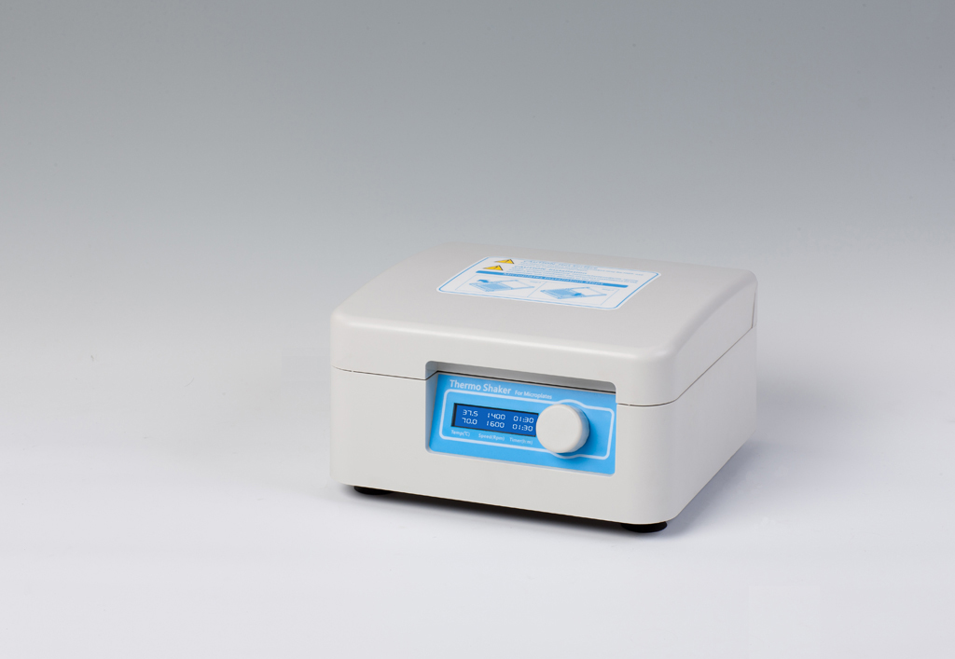
Description:
TS200 Thermo Shaker for Microplates is with technique of brushless DC motor and PID intelligent temperature control. Mainly used for shaking and cultivation in elisa plates (96/384 wells) or 96 wells tissue culture plates.
Features:
- LCD displays system status and parameters.
- Stable and reliable operation with high quality switch.
- Easy to operate with one touch knob.
- Set-up the time within 0~100hours, instrument will make alarm voice when completing.
- With power recovery, instrument will be continuous to run when power recovers from outage.

Applications:
- Storing enzymes or DNA libraries at your workstation.
- Transporting samples from the field at exactly the right temperature.
- Heating samples in the field.
- Enzyme reactions and deactivations.
- PCR sample preparation.
Type  Parameter | TS200
Temp. range | RT.+5℃ ~80℃
Timing range | 1min ~ 99h59min
Speed range | 200 ~ 1600rpm
Orbit | 3mm
Temp. Accuracy | ≤±0.5℃
Display Accuracy | 0.1℃
Temp. Uniformity | ≤±0.5℃
Heating time | ≤10min(from RT. to 80℃)
Sample capacity | 2pcs microplates or culture plates
Heating part | Heating film
Power | 150W
Voltage | AC220V or 110V/50~60Hz
Dimension(mm) | 280×270×140
Weight(kg) | 7.0

